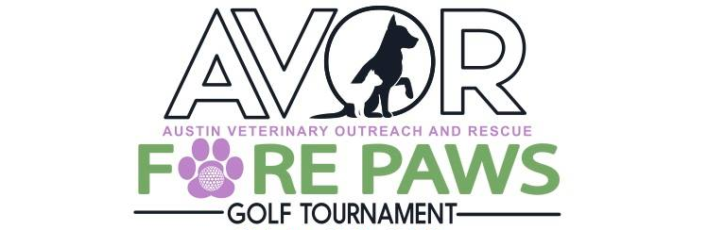
thursday, april 27, 2023
SPONSORSHIP PACKAGES
SPONSOR - $1000 X_________= $__________

- Two (2) Complimentary Foursome Package, Tee/Green sign with name
- Special Recognition at event, website and Facebook page
- Display corporate banner at event
SPONSOR - $500 X_________= $_________

- Complimentary Foursome Package
- Tee/Green sign with name of company or pet
- Display corporate banner at event

SPONSOR - $300 X_________= $__________

- Complimentary Twosome Package, Tee/Green sign with name
- Tee/Green sign with name of company or pet

SPONSOR - $100 X_________= $__________

- Tee/Green sign with name of company or pet

Contact Name: ___________________________ Ph #:___________________________________
Email Address: ___________________________________________________________________

Forms can be mailed to: AVOR, P.O. Box 651, Beaufort, NC 28516
or drop off at: The Golf Farm, Newport or Austin Veterinary
Checks payable to AVOR. Send LOGO art to austinvetoutreach@gmail.com

