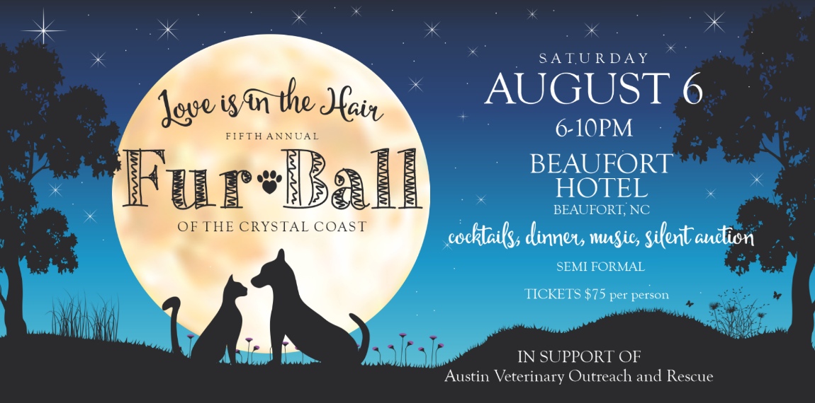
SPONSORSHIP PACKAGES

- Bronze Sponsor - $150 - Recognition of Business (or individual) on the AVOR Facebook page, in the running PowerPoint at the ball, and a blurb in the event program.

- Silver Sponsor - $250 - 2 Tickets to the event, Recognition of Business (or individual) on the AVOR Facebook page and in the running PowerPoint at the ball, a blurb in the event program, and a table displaying business promotional materials.

- Gold Sponsor - $500 - 4 Tickets to the event, Recognition of Business (or individual) on the AVOR Facebook page and in the running PowerPoint at the gala, a blurb in the event program, a table displaying business promotional materials and a table at the event.

- Platinum Sponsor - $1,000 - 6 Tickets to the event, Recognition of Business (or individual) on the AVOR Facebook page and in the running PowerPoint at the gala, a blurb in the program, a silent auction table advertising their business, a table at the event, and a banner with the company's logo displayed at the event.

- Silent Auction Donation - donation of goods to be displayed and auctioned at the event.
Sponsor Information:

Please circle your sponsorship level above.

Sponsor Name: ___________________________________________________________

Phone Number: _______________________Email address: ________________________

Sponsor Address: __________________________________________________________

Please send form to: A.V.O.R., P.O. Box 651 Beaufort, NC 28516. Checks payable to: A.V.O.R.
To ensure proper recognition at the Fur Ball please send logo art to: austinvetoutreach@gmail.com

For any questions or additional information, please contact AVOR at 252-732-5936

